

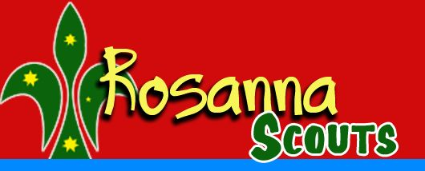
59th Melbourne Gang Show,
Family BBQ & Cub Sleepover!
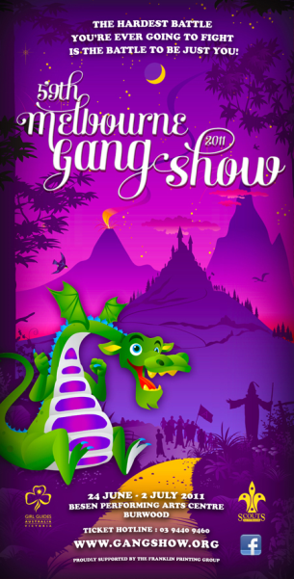
The Scouts and Guides of Victoria present the 59th Melbourne Gang Show, at the Besen Centre, Burwood.

See also: http://www.gangshow.org

Rosanna Cubs & Scouts (& parents, siblings etc., welcome too!) will attend the 2pm performance on Saturday, 25th of June.

Following the performance, we’ll be coming back to the Hall for a family BBQ, and then the parents and siblings will leave and the Cubs will have a sleepover in the Hall.

This Year we’ll again be joining up with 1st Bendigo Cubs, who will come along to our BBQ and Sleepover after Gang Show!

Costs for the performance (bulk discount) are:
- Adults: $20
- Children: $14
- Family BBQ: $5 per person.


➔ We need to get our bookings in for the show as soon as possible, to enable us to get the best possible seats at the performance. Once we’ve put the booking in, you may still be able to buy tickets for the performance, but you’ll be seated elsewhere in the theatre and the ticket prices will be $5 higher due to missing the bulk discount.

Please return the tear off form below – RETURN IT with money 1st night back BUT please email me now! We’ll then get our tickets organised.
Come along and have a ball!

59th Melbourne Gang Show, 2011
We’re coming along….
(1) Family Name:______________________ Cub(s)/Scout(s):______________________

(2) TOTAL tickets required (including Cubs & Scouts): Adults ($20):__________________ = $____

Child ($14): __________________ = $____

(3) Attending the BBQ? Adults ($5): ______________ + Child ($5): _______________ = $____

Money required for Scouts – 27/4, Cubs 3/5, so we can get tickets organised. Total: = $____
If paying by Cheque, please make payable to “Wayne Renfrew”, as I’ll be buying tickets and getting reimbursed

(4) Cub(s) staying for sleepover (Free!) – Name(s): _____________________________

Please email NOW re Gang Show numbers, to akela@rosannacubs.org

